**Project Design Phase-II(Requirement analysis)**

**Data Flow Diagram & User Stories**

|  |  |
| --- | --- |
| Date | 15 june 2025 |
| Team ID | LTVIP2025TMID46320 |
| Project Name | Doc Spot |
| Maximum Marks | 4 Marks |

**Data Flow Diagrams:**

The Data Flow Diagram (DFD) of DocSpot illustrates how data moves within the system between users (patients, doctors, admin) and internal processes.

Patients can register, log in, view doctors, and book appointments.

Doctors can register, log in, set availability, and manage appointments.

Admins review and approve doctor profiles and monitor the system.

**The system includes modules like:**

User Authentication

Appointment Booking

Doctor Availability Management

Admin Management

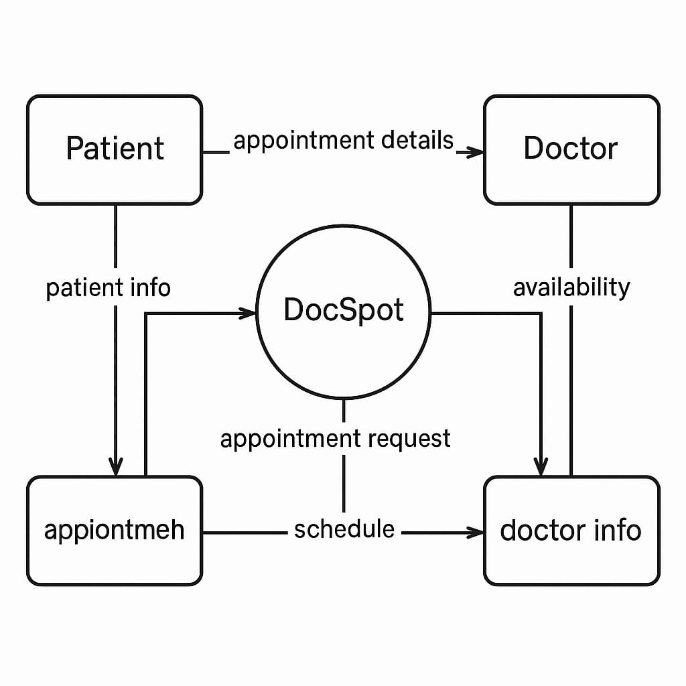**DATA-FLOW DIAGRAM:**

**User Stories**

Use the below template to list all the user stories for the product.

| **User Type** | **Functional Requirement (Epic)** | **User Story Number** | **User Story / Task** | **Acceptance criteria** | **Priority** | **Release** |
| --- | --- | --- | --- | --- | --- | --- |
| Customer (Mobile user) | Registration | USN-1 | As a user, I can register for the application by entering my email, password, and confirming my password. | I can access my account / dashboard | High | Sprint-1 |
| Customer (Mobile user) | Registration | USN-2 | As a user, I will receive confirmation email once I have registered for the application | I can receive confirmation email & click confirm | High | Sprint-1 |
| Customer (Mobile user) | Registration | USN-3 | As a user, I can register for the application through Facebook | I can register & access the dashboard with Facebook Login | Low | Sprint-2 |
| Customer (Mobile user) | Registration | USN-4 | As a user, I can register for the application through Gmail | I can log in successfully using Gmail and reach dashboard | Medium | Sprint-1 |
| Customer (Mobile user) | Login | USN-5 | As a user, I can log into the application by entering email & password | I am logged in and redirected to dashboard | High | Sprint-1 |
| Customer (Mobile user) | Dashboard | USN-6 | |  | | --- | |  |  |  | | --- | | As a user, I can view upcoming appointments and health notifications. | | Dashboard displays appointments, alerts, and upcoming events | High | Sprint-2 |
| Customer (Mobile user) | Book Appointment | USN-7 | As a user, I can search for doctors and book an appointment. | I get confirmation of booking with time, doctor details | High | Sprint-2 |
| Customer (Web user) | Dashboard | USN-8 | As a user, I can log in from a browser and view appointment history. | My dashboard is accessible via web browser | High | Sprint-2 |
| Customer Care Executive | Profile Settings | USN-9 | As a user, I can edit my profile details. | I can update name, phone, gender, etc., and save successfully | Medium | Sprint-3 |
| Administrator | View Appointments | USN-10 | As a care executive, I can view upcoming bookings for all users. | List of all appointments with filter/sort options | Medium | Sprint-3 |
| Administrator | Contact Patients | USN-11 | As a care executive, I can contact patients for confirmation or follow-up. | Option to send SMS/Call or email from dashboard | Medium | Sprint-4 |
| Administrator | Manage Doctors | USN-12 | As an admin, I can approve or reject doctor profile applications | Doctor's status is updated and notification is sent | High | Sprint-3 |
| Administrator | View System Metrics | USN-13 | As an admin, I can see total users, doctors, appointments in dashboard. | Analytics dashboard is visible with charts and stats | Medium | Sprint-4 |